Operating System (22516)
Unit -III
Process Management (Marks 14)
3.1 Process-: process states,Process Control Block (PCB)
3.2 Process Scheduling- scheduling Queues,Schedulars,Context switch.
3.3 Inter-process communication(IPC): Introduction, shared memory system and message passing system.
3.4 Threads – Benefits, users and kernel threads, Multithreading Models- Many to One, One to One, Many to Many.
3.5 Execute process commands- like ps,wait,sleep,exit,kill

PROCESS CONCEPT
Processes & Programs:
- Process is a dynamic entity. A process is a sequence of instruction. Process exists in a limited span of time. Two or more process may execute the same program by using its own data & resources.
- A program is a static entity which is made up of program statement. Program contains the instruction. A program exists in a single space. A program does not execute by itself. It does not compete for computing resources like CPU or the memory. But process does.
- A program is created by user whereas a process is created by OS.
- A process generally consists of a process stack which consists of temporary data & data section which consists of global variables.
- It also contains program counter which represents the current activities.
Process

A process is a program in execution. The execution of a process must progress in a sequential fashion.
Components of process
1. A text section
It contains the program code.
2. A Program Counter
It contains the address of next instruction to be executed.
3. Stack section
It contains the temporary data.
4. Data section
This section contains the values of global variables.
5. Heap section
It keeps the track of dynamically allocated memory while executing a process.

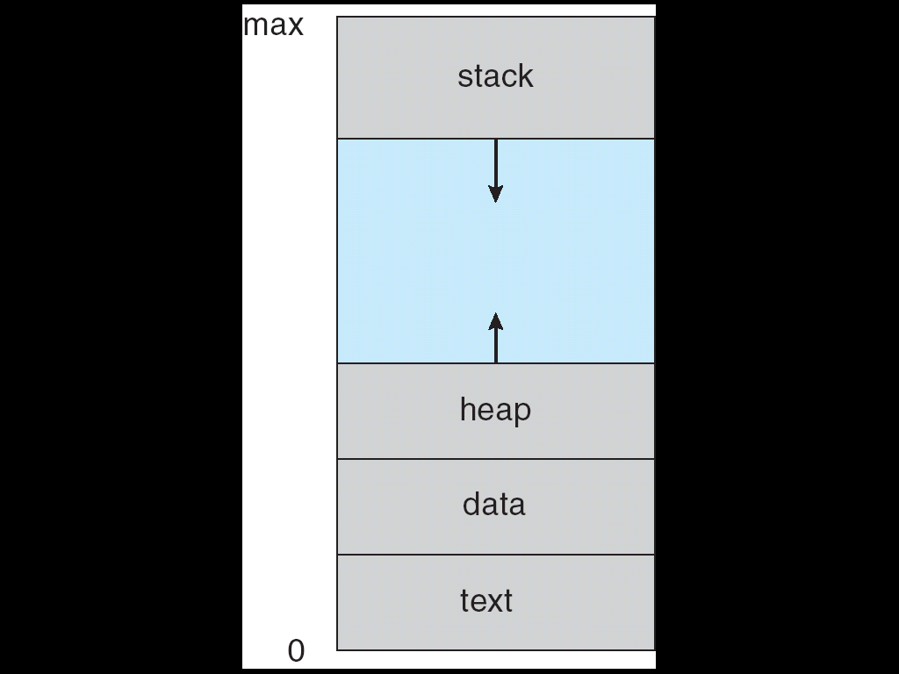

Process | Program
1. Process is a program in execution. | A program is a series of instructions to perform a specific task.
2. Process is a dynamic entity | A program is a static entity
3. A process is created by OS. | A program is created by user
4. A process is present in main memory | A program is present on secondary storage
5. Process compete for computing | Program does not compete for computing

Process State
When process executes, it changes state. Process state is defined as the current activity of the process. Fig. shows the general form of the process state transition diagram. Process state contains five states. Each process is in one of the states. The states are listed below.
1. New
2. Ready
3. Running
4. Waiting
5. Terminated (exist)
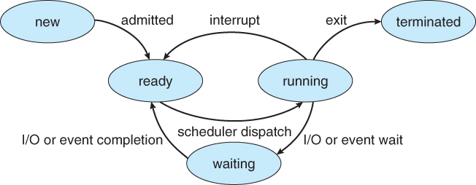
Fig. Process states and state transitions
1. New: A process that is just been created. The new process might wait as a new process if there are too many processes in a ready queue.
2. Ready: Ready processes are processes that are waiting to have the processor allocated to them by the operating system so that they can run.
3. Running: The process that is currently being executed. A running process possesses all the resources needed for its execution, including the processor.
4. Waiting: When a process is waiting for an external event such as an I/O operation, it is said to be in blocked or waiting state.
5. Terminated: A process that has been released from the pool of executable processes by the operating system is said to be in terminated.

Process Control Block (PCB)
Each process contains the process control block (PCB). PCB is the data structure used by the operating system. Operating system groups all information that needs about particular process. Following fig. shows the process control block.
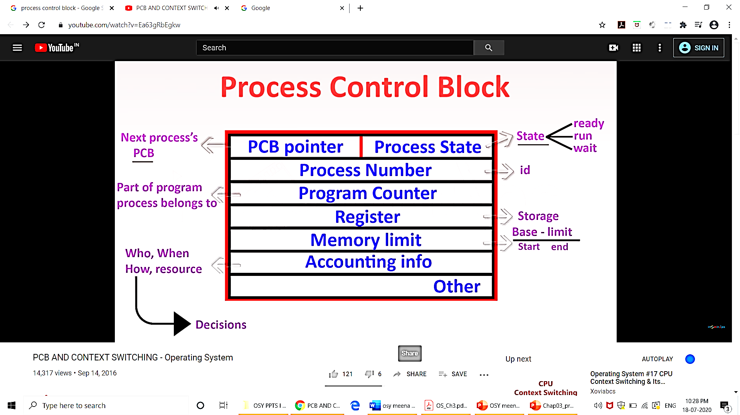
1. Pointer: Pointer points to another process control block. Pointer is used for maintaining the scheduling list.
2. Process State: Process state may be new, ready, running, waiting and so on.
3. Program Counter: It indicates the address of the next instruction to be executed for this process.
4. CPU register: It indicates general purpose register, stack pointers, index registers and accumulators etc. number of register and type of register totally depends upon the computer architecture.
5. CPU scheduling: CPU scheduling handles the removal of running process from the CPU and the selection of another process on the basis of particular scheduling algorithm used.
6. Memory Management Information: This information may include the value of base and limit register. This information is useful for deallocating the memory when the process terminates.
7. Accounting Information: This information includes the amount of CPU and real time used, job or process numbers, account numbers etc.
8. I/O status information: It keeps the track of I/O devices which are allocated to the processes and number of open and close files.

Process control block also includes the information about various events, file management information, priority and so on.
The PCB simply serves as the repository for any information that may vary from process to process.
When a process is created, hardware registers and flags are set to the values provided by the loader or linker. Whenever that process is suspended, the contents of the processor register are usually saved on the stack and the pointer to the related stack frame is stored in the PCB. In this way, the hardware state can be restored when the process is scheduled to run again.

Process Scheduling:
In multiprogramming operating system, more than one process are loaded into the main memory at a time and the loaded processes share the CPU using time multiplexing.
If only one CPU is available, choice has to be made which process to run next. The part of operating system that makes this choice is called the process scheduler.

3.3.1 Scheduling Queues
When the process enters into the system, it is put into a job queue. This queue consists of all processes in the system. The processes ready and waiting for execution are kept in a list called ready queue. The ready queue is implemented as linked list. The header of ready queue points to the first and last Process Control Block and each PCB has a pointer to next PCB in the ready queue.
Device queue is a queue in which a list of processes wait for a particular I/O device. Each device has its own device queue.

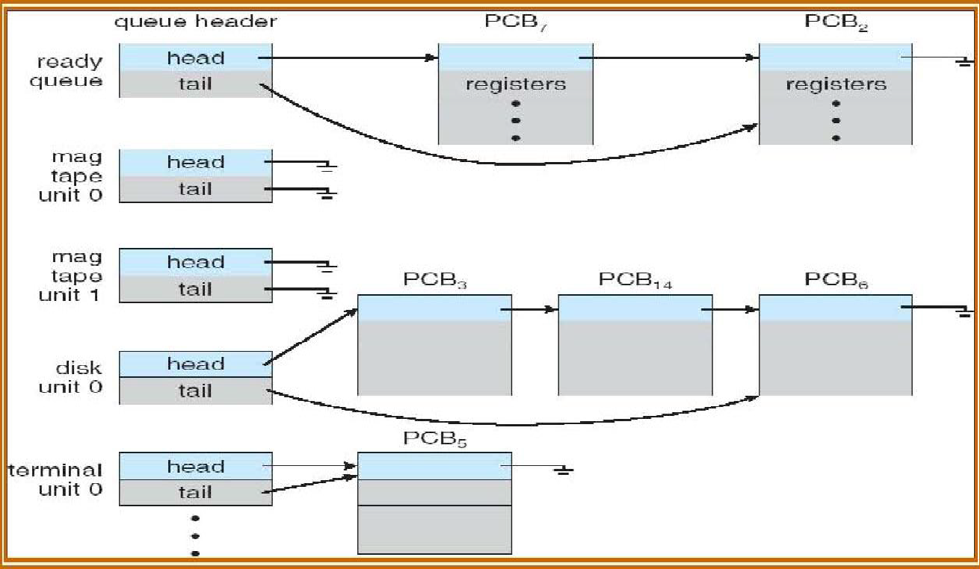
Fig. The ready queue and various device queues

Fig. shows the queuing diagram of process scheduling. In the fig 3.3, queue is represented by rectangular box. The circles represent the resources that serve the queues. The arrows indicate the flow of processes in the system.

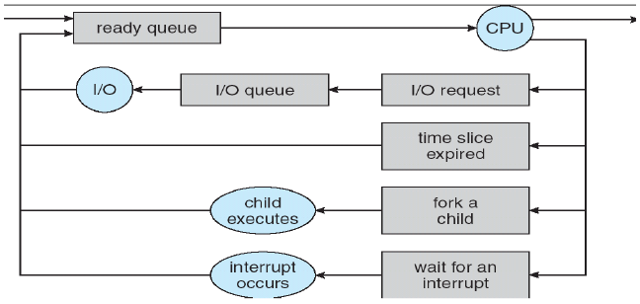

Queues are of two types - Ready queue and I/O queue. A newly arrived process is put in the ready queue. Processes are waiting in ready queue for allocating the CPU. Once the CPU is assigned to the process, then process will execute. While executing the process, one of the several events could occur.

1. The process could issue an I/O request and then OS places it in an I/O queue.
2. The process could create new sub process and waits for its termination.
3. The process could be removed forcibly from the CPU, as a result of interrupt and put back in the ready queue.

Two State Process Model
Process may be in one of two states :
a) Running
b) Not Running

When new process is created by OS, that process enters into the system in the running state.
Processes that are not running are kept in queue, waiting their turn to execute. Each entry in the queue is a printer to a particular process. Queue is implemented by using linked list. Use of dispatcher is as follows. When a process interrupted, that process is transferred in the waiting queue. If the process has completed or aborted, the process is discarded. In either case, the dispatcher then select a process from the queue to execute.

Schedulers
Schedulers are of three types-
1. Long Term Scheduler
2. Short Term Scheduler
3. Medium Term Scheduler

- Long Term Scheduler
- It is also called job scheduler.
- If the number of ready processes in the ready queue increases, the overhead on operating system for maintaining long list, context switching and dispatching increases. Therefore, only the limited processes are allowed in the ready queue to compete for the CPU. This is managed by the long term scheduler.
- The primary objective of the long term scheduler is to provide a balanced mix of jobs or processes, such as I/O bound and processor bound.
- It also controls the degree of multiprogramming. If the degree of multiprogramming is stable, then the average rate of process creation must be equal to the average departure rate of processes leaving the system.
Note:
I/O bound process: This type of process spends more time in doing input/output operation than doing computations.
CPU bound process: This type of process generated I/O request rarely and spends more time in doing computations.
- Short Term Scheduler
- It is also called CPU scheduler or dispatcher.
- Main objective is increasing system performance in accordance with the chosen set of criteria.
- Short term scheduler selects a process from the ready queue based on scheduling algorithm used and allocates a processor to it.
- Short term scheduler executes most frequently and is faster than long term scheduler.

- Medium Term Scheduler
- The main memory of the computer is limited and it can hold only a certain number of processes.
- If sufficient memory for process execution is not available, the process gets blocked and it is swapped out on the disk.

Medium Term Scheduler
Blocked and ready swapped out processes

CPU
Ready Queue

Long Term Scheduler
New Jobs
Short Term Scheduler
Blocked processes queue

- When some memory is freed, the operating system checks the swapped but ready processes.
- Depending upon the priority of memory requirement, the operating system decides which process is to be swapped in.
- After swapping it in the OS links the process control block to the chain of ready processes for dispatching. This is the function of medium term scheduler.
Comparison between Scheduler
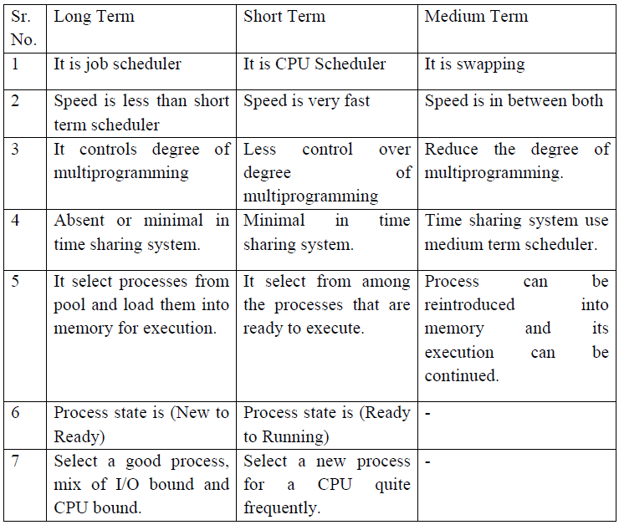
Context Switch
- When the scheduler switches the CPU from one process to another, the context switcher saves the content of all processor registers for the process being removed from the CPU in its Process Control Block and loading the saved information of the new process.
- Context switch time is pure overhead. Context switching can significantly affect performance, since modern computers have a lot of general and status registers to be saved.
- When the execution of any currently executing process is stopped due to some reason, processor takes another process for execution. Before starting the execution of another process, the status or context of the original process is saved in its register save area in the PCB of the process and the context of the new process is being loaded.

When the process is switched the information stored is :
1. Program Counter
2. Scheduling Information
3. Base and limit register value
4. Currently used register
5. Changed State
6. I/O State
7. Accounting

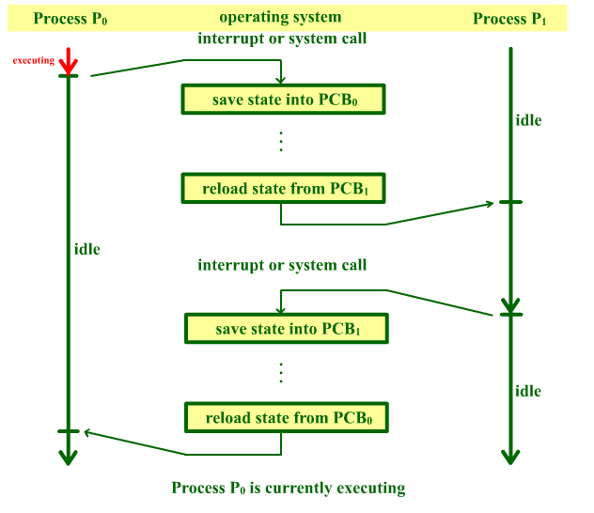

Operations on Processes
Several operations are possible on the process. Process must be created and deleted dynamically. Operating system provide a mechanism for process creation and termination.

- Process Creation:
- Operating system creates a new process with the specified or default attributes and identifier. A process may create several new sub processes.
- Two names are used in the process they are parent process and child process.
- Parent process is a creating process. Child process is created by the parent process.
- Child process may create another sub process. So it forms a tree of processes.
- When operating system issues a CREATE system call, a new process is created by an existing process.
When a process is created, it requires some parameters.
- From list of free PCBs, the operating system aquires a free PCB.
- It assigns a process ID to the new process.
- It updates the free PCB header.
- With the help of information management, the OS gets the location of the sub program file on the disk, its size and the address of first executable instruction.
- By memory management, OS search for the free memory area in the main memory.
- Then the program is actually loaded into the allocated memory locations.
- The OS determines the initial priority of the process.
- The following field for of PCB for the child process are initialized:
    - Process ID
    - Process State
    - Process Priority
    - Register Save Area(Program Counter , Stack Pointer etc)
    - Pointer to memory area
    - Pointer to other resources
    - List of open files
- The OS links the PCB to list of ready processes.
- The OS updates the master list of all known processes.

- These are priority, level of privilege, requirement of memory, access right, memory protection information etc. Process will need certain resources, such as CPU time, memory, files and I/O devices to complete the operation. When process creates a sub process, that sub process may obtain its resources directly from the operating system. Otherwise it uses the resources of parent process.
- When a process creates a new process, two possibilities exist in terms of execution.
1. The parent continues to execute concurrently with its children.
2. The parent waits until some or all of its children have terminated.
For address space, two possibilities occur:
1. The child process is a duplicate of the parent process.
2. The child process has a program loaded into it.

________________________________________________

Terminate a Process
The process is terminated by executing the exit() system call.

The Process Terminates due to one of the following reasons-
- Normal exit(Voluntary)
After completion of a process the process terminates.
- Error exit(voluntary)
This reason for termination is an error due to a program bug.
e.g executing an illegal instruction, referencing non existent memory or divide by zero.
- Fatal Error(Involuntary)
In this case if a user tries to compile a program which does not exist, then the compiler simply exits.
- Killed by another process
A process executes a system call telling the operating system to kill some other process.
The operating system performs following tasks for process termination:
- The system call for process termination is generated and the operating system routine starts executing.
- The Process ID is stored for future reference.
- Operating system accesses the PCB and frees the memory and resources allocated to the process.
- The OS checks the list of open files and makes sure that they are closed.
- Then the PCB is added to the end of the list of free PCB.
- The master list of known processes is updated.

Inter Process Communication:
Processes need to exchange information with each other. Various system calls are used during this information exchange.
● create, delete communication connection
● send, receive messages
● transfer status information
● attach or detach remote devices
There are two types of inter-process communication:
- Message passing model
- B)shared memory
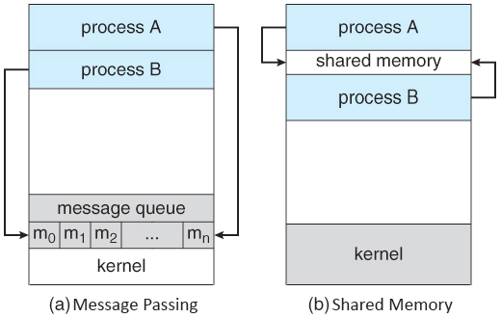
Inter-process communication:
Cooperating processes require an Inter- process communication (IPC) mechanism that will allow them to exchange data and information. There are two models of IPC
Shared memory: In this a region of the memory residing in an address space of a process creating a shared memory segment can be accessed by all processes who want to communicate with other processes.
  - All the processes using the shared memory segment should attach to the address space of the shared memory.
  - All the processes can exchange information by reading and/or writing data in shared memory segment.
  - The form of data and location are determined by these processes who want to communicate with each other.
  - These processes are not under the control of the operating system. The processes are also responsible for ensuring that they are not writing to the same location simultaneously.
  - After establishing shared memory segment, all accesses to the shared memory segment are treated as routine memory access and without assistance of kernel.
Message Passing:
- In this model, communication takes place by exchanging messages between cooperating processes.
- It allows processes to communicate and synchronize their action without sharing the same address space.
- It is particularly useful in a distributed environment when communication process may reside on a different computer connected by a network. Communication requires sending and receiving messages through the kernel.
- The processes that want to communicate with each other must have a communication link between them. Between each pair of processes exactly one communication link

Threads
- A thread is known as light weight process.
- It is also known as a basic unit of CPU utilization.
- A thread is associated with thread ID, program counter, register set and a stack.
- A thread is similar to a task.

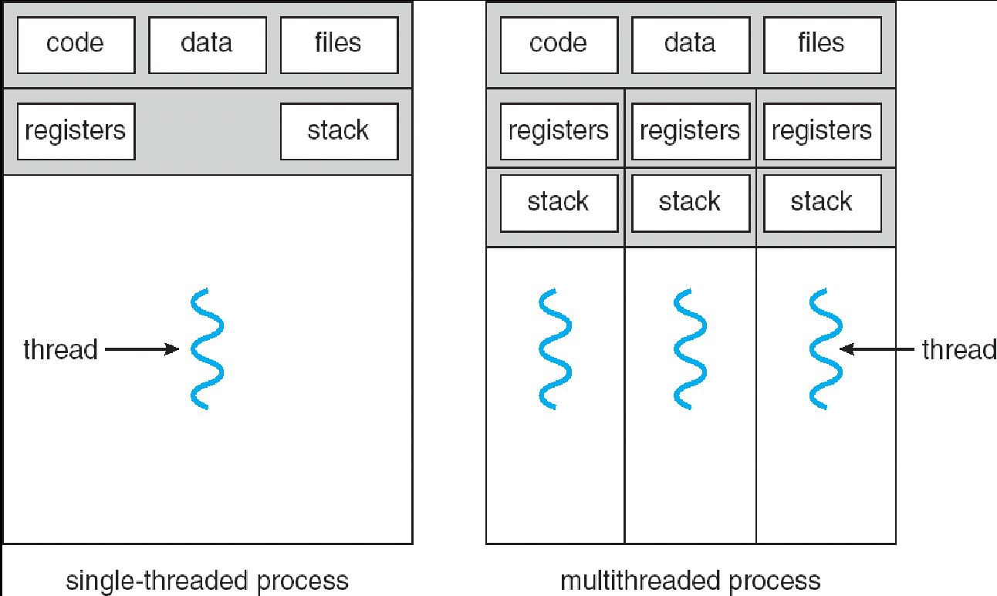

- Traditional process has a single thread of control.
- If a process has multiple threads then it can perform more than one tasks at a time.
Examples:
- Word processing is one of the example of multithreading. When word processor is running it uses multiple threads i.e. one thread for displaying graphics, one thread for checking the spelling and grammar and various other threads for performing different operations.
- A web browser also has many threads i.e one thread may display images , one thread displays text, one thread used for links like data from network etc.
Multithreaded system can perform better than single threaded system.

Advantages of Thread
- Thread minimizes context switching time.
- Use of threads provides concurrency within a process.
- Efficient communication.
- Economy- It is more economical to create and context switch threads.
- Utilization of multiprocessor architectures to a greater scale and efficiency.

Difference between Process and Threads
Process | Thread
Process is heavy weight or resource intensive. | Lightweight process or part of it.
Process switching needs interaction with operating system. | Thread switching does not need interaction with operating system.
In multiple processing environments each process executes the same code but has its own memory and file resources. | Threads of same process shares memory and resources with each other.
If one process is blocked then no other process can execute until the first process is unblocked. | If one thread is blocked then another thread of same process can execute.
Multiple processes without using threads use more resources. | Multiple processes without using threads use more resources.
In multiple processes each process operates independently of the others. | In multiple processes each process operates independently of the others.

Types of Thread
Threads is implemented in two ways :
- User Level
- Kernel Level

User Level Thread
- In a user thread, all of the work of thread management is done by the application and the kernel is not aware of the existence of threads.
- The thread library contains code for creating and destroying threads, for passing message and data between threads, for scheduling thread execution and for saving and restoring thread contexts.
- The application begins with a single thread and begins running in that thread.
User level threads are generally fast to create and manage.
Advantage of user level thread over Kernel level thread :
1. Thread switching does not require Kernel mode privileges.
2. User level thread can run on any operating system.
3. Scheduling can be application specific.
4. User level threads are fast to create and manage.

Disadvantages of user level thread :
1. In a typical operating system, most system calls are blocking.
2. Multithreaded application cannot take advantage of multiprocessing.

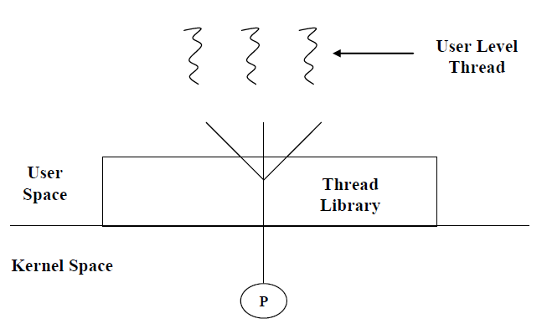
Kernel Level Threads
- In Kernel level thread, thread management done by the Kernel.
- There is no thread management code in the application area.
- Kernel threads are supported directly by the operating system.
- Any application can be programmed to be multithreaded.
- All of the threads within an application are supported within a single process.
- The Kernel maintains context information for the process as a whole and for individuals threads within the process.
- Scheduling by the Kernel is done on a thread basis.
- The Kernel performs thread creation, scheduling and management in Kernel space.
- Kernel threads are generally slower to create and manage than the user threads.

Advantages of Kernel level thread:
1. Kernel can simultaneously schedule multiple threads from the same process on multiple process.
2. If one thread in a process is blocked, the Kernel can schedule another thread of the same process.
3. Kernel routines themselves can multithreaded.

Disadvantages:
1. Kernel threads are generally slower to create and manage than the user threads.
2. Transfer of control from one thread to another within same process requires a mode switch to the Kernel.

Multithreading Models
Some operating system provide a combined user level thread and Kernel level thread facility. Solaris is a good example of this combined approach. In a combined system, multiple threads within the same application can run in parallel on multiple processors and a blocking system call need not block the entire process.

Multithreading models are three types:
- Many to many relationship.
- Many to one relationship.
- One to one relationship.

Many to many (M:N)relationship
- In this model, many user level threads are mapped to the Kernel thread of smaller or equal numbers.
- The number of Kernel threads may be specific to either a particular application or a particular machine.
- In this model, developers can create as many user threads as necessary and the corresponding Kernel threads can run in parallels on a multiprocessor.
- When one thread call block system call, other kernel thread calls for another system call.

User Space scheduler

U
1
U
N
U
3
U
2

User Threads

Kernel Threads

K
2

K
1

K
N

Kernel Space scheduler

Fig. Many to Many Model

Many to One Model
- Many to one model maps many user level threads to one Kernel level thread.
- Thread management is done in user space.
- When thread makes a blocking system call, the entire process will be blocked.
- Only one thread can access the Kernel at a time, so multiple threads are unable to run in parallel on multiprocessors.
- If the user level thread libraries are implemented in the operating system in such a way that system does not support them then Kernel threads use the many to one relationship modes.

U
N
U
3
U
2
U
1

User Threads

Kernel Threads
K
1

Fig. Many to One Model

One to One Model
- There is one to one relationship of user level thread to the kernel level thread.
- This model provides more concurrency than the many to one model.
- It also another thread to run when a thread makes a blocking system call.
- It support multiple thread to execute in parallel on microprocessors.
- Disadvantage of this model is that creating user thread requires the corresponding Kernel thread.
- OS/2, Windows NT and windows 2000 use one to one relationship model.

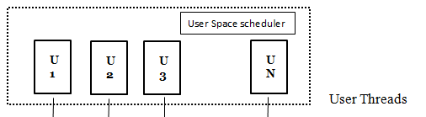
Kernel Threads

K
2
K
N

K
1

K
3

Fig. One to One Model

Difference between User Level Threads Kernel Level Thread

S.N. | User Level Threads | Kernel Level Thread
1 | User level threads are faster to create and manage. | Kernel level threads are slower to create and manage.
2 | Implementation is by a thread library at the user level. | Operating system supports creation of Kernel threads.
3 | User level thread is generic and can run on any operating system. | Kernel level thread is specific to the operating system.
4 | Multi-threaded application cannot take advantage of multiprocessing. | Kernel routines themselves can be multithreaded.

